Harrow Bay offshore substation topside safely installed
Press release
Noah Fischer · 19 August 2026
Edinburgh, 19 August 2026 – The topside of the Harrow Bay offshore substation (HB-OSS) has been lifted onto its jacket foundation in a single lift. The 3,900-tonne module collects the power from the 40 turbines and steps it up to 220 kV for transmission to shore through two 62-kilometre export cables.
“A textbook lift in a perfect weather window,” said Elena Márquez, Project Director. “With the substation in place and eleven monopiles in the seabed, Harrow Bay is clearly taking shape.”
Foundation installation continues, and cable laying is scheduled to start in spring 2027.
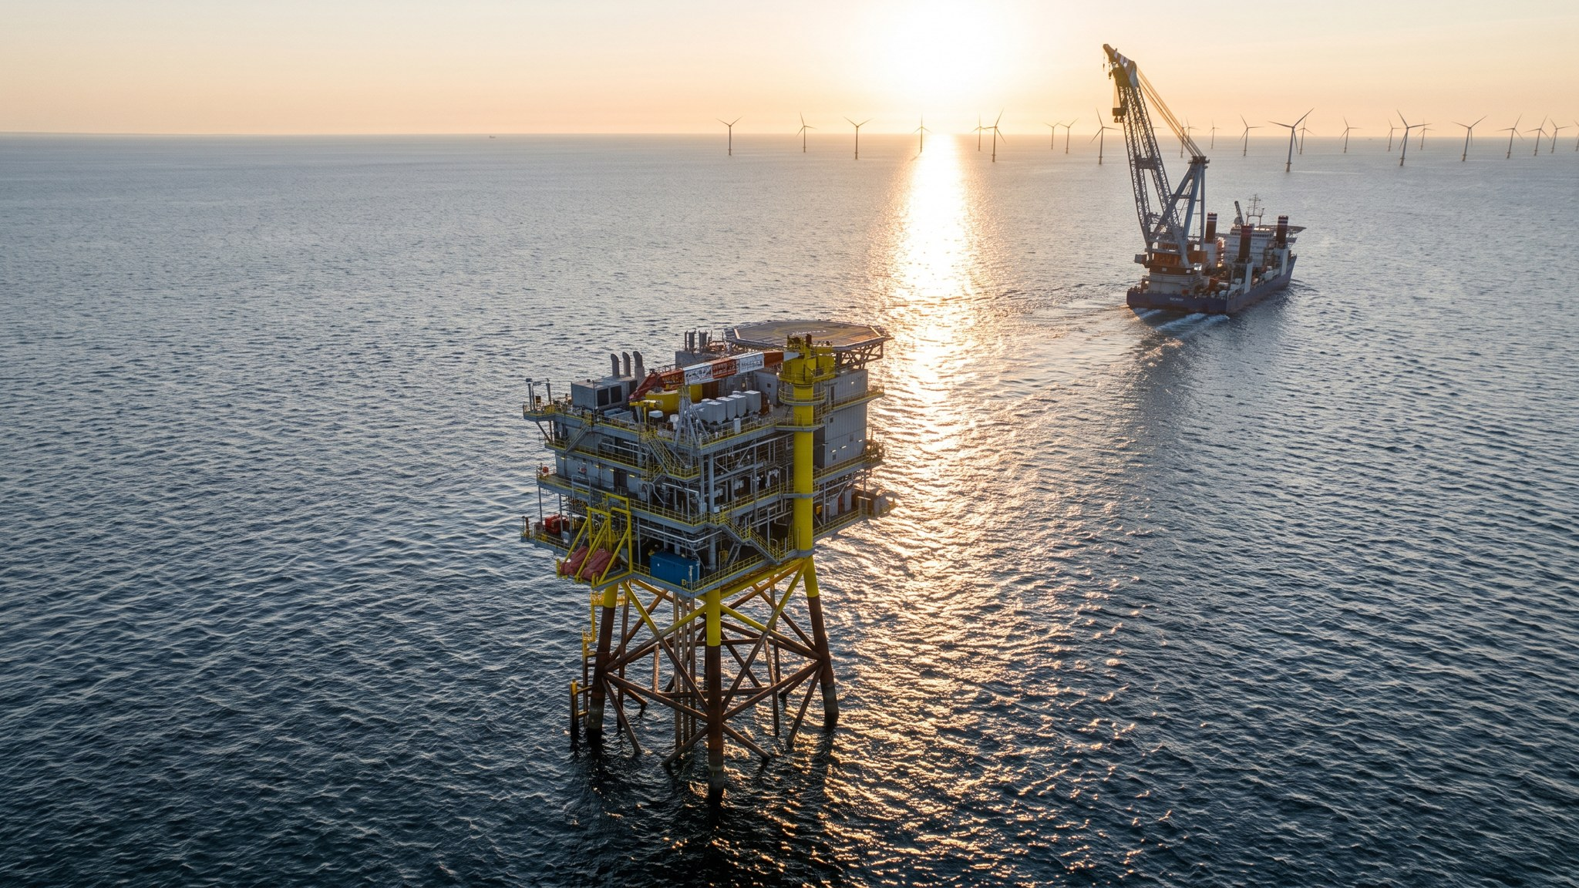
The HB-OSS topside on its jacket, 19 August 2026.
Media contact: Noah Fischer, Marketing & Communications Manager · press@weyland-energy.example · +49 40 3290 4410
About Weyland Energy. Weyland Energy GmbH develops, builds and operates wind, solar and storage assets across Northern Europe. Founded in 2011 and headquartered in Hamburg with offices in Edinburgh and Copenhagen, the company employs around 450 people, operates 1,100 MW of renewable capacity and has a development pipeline of 4.2 GW. In 2025 its assets avoided 1.2 million tonnes of CO₂. Clean power, built to last.

